Họ và Tên: Nguyễn Phương Thiên Vũ
MSSV: 1250080237
Lớp: 12_ĐH_CNTT5

Phiếu bài tập 1

a. Thủ tục sp_NhapHangSX
CREATE OR REPLACE PROCEDURE sp_NhapHangSX (
p_MaHangSX IN VARCHAR2,
p_TenHang IN VARCHAR2,
p_DiaChi IN VARCHAR2,
p_SoDT IN VARCHAR2,
p_Email IN VARCHAR2
) AS
v_count NUMBER := 0;
BEGIN
SELECT COUNT(*) INTO v_count FROM HangSX WHERE TenHang = p_TenHang;
IF v_count > 0 THEN
DBMS_OUTPUT.PUT_LINE('TenHang da ton tai');
ELSE
INSERT INTO HangSX (MaHangSX, TenHang, DiaChi, SoDT, Email)
VALUES (p_MaHangSX, p_TenHang, p_DiaChi, p_SoDT, p_Email);
COMMIT;
END IF;
END sp_NhapHangSX;
/
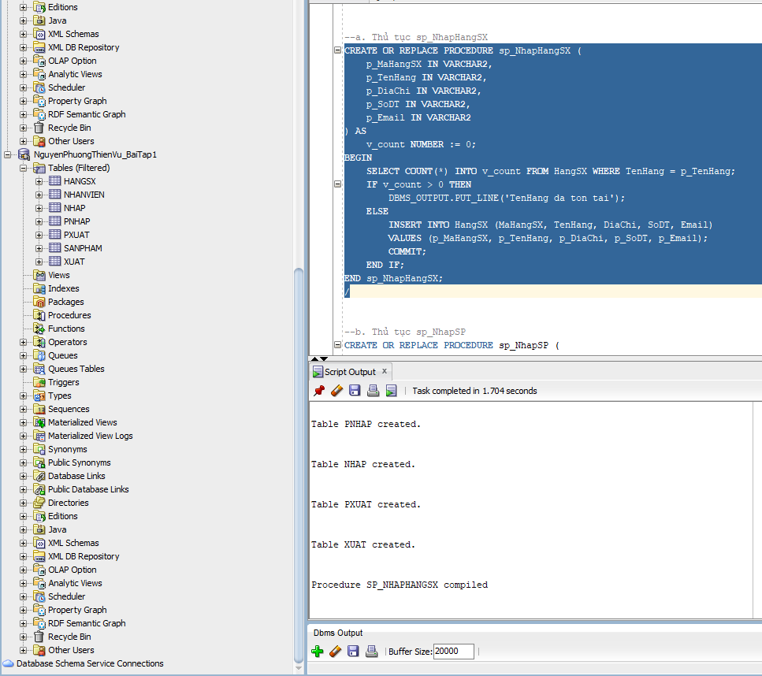
b. Thủ tục sp_NhapSP
CREATE OR REPLACE PROCEDURE sp_NhapSP (
p_MaSP IN VARCHAR2,
p_TenHang IN VARCHAR2,
p_TenSP IN VARCHAR2,
p_SoLuong IN NUMBER,
p_MauSac IN VARCHAR2,
p_GiaBan IN NUMBER,
p_DonViTinh IN VARCHAR2,
p_MoTa IN CLOB
) AS
v_MaHangSX VARCHAR2(10);
v_count NUMBER := 0;
BEGIN
-- Kiểm tra TenHang tồn tại
SELECT COUNT(*) INTO v_count FROM HangSX WHERE TenHang = p_TenHang;
IF v_count = 0 THEN
RETURN;
END IF;

SELECT MaHangSX INTO v_MaHangSX FROM HangSX WHERE TenHang = p_TenHang;

SELECT COUNT(*) INTO v_count FROM SanPham WHERE MaSP = p_MaSP;
IF v_count > 0 THEN
UPDATE SanPham
SET MaHangSX = v_MaHangSX, TenSP = p_TenSP, SoLuong = p_SoLuong, MauSac = p_MauSac,
GiaBan = p_GiaBan, DonViTinh = p_DonViTinh, MoTa = p_MoTa
WHERE MaSP = p_MaSP;
ELSE
INSERT INTO SanPham (MaSP, MaHangSX, TenSP, SoLuong, MauSac, GiaBan, DonViTinh, MoTa)
VALUES (p_MaSP, v_MaHangSX, p_TenSP, p_SoLuong, p_MauSac, p_GiaBan, p_DonViTinh, p_MoTa);
END IF;
COMMIT;
END sp_NhapSP;
/
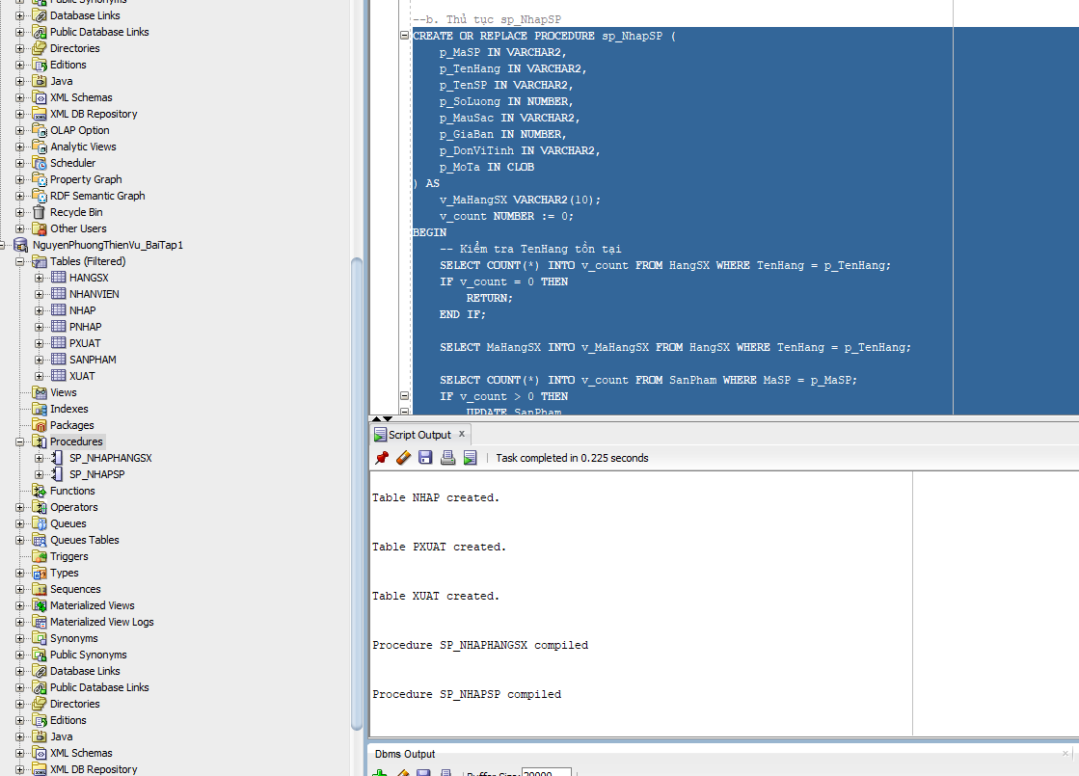
c. Thủ tục sp_xoaHangSX
CREATE OR REPLACE PROCEDURE sp_xoaHangSX (
p_TenHang IN VARCHAR2
) AS
v_MaHangSX VARCHAR2(10);
v_count NUMBER := 0;
BEGIN
SELECT COUNT(*) INTO v_count FROM HangSX WHERE TenHang = p_TenHang;
IF v_count = 0 THEN
DBMS_OUTPUT.PUT_LINE('TenHang chua ton tai');
RETURN;
END IF;

SELECT MaHangSX INTO v_MaHangSX FROM HangSX WHERE TenHang = p_TenHang;

DELETE FROM Nhap WHERE MaSP IN (SELECT MaSP FROM SanPham WHERE MaHangSX = v_MaHangSX);
DELETE FROM Xuat WHERE MaSP IN (SELECT MaSP FROM SanPham WHERE MaHangSX = v_MaHangSX);
DELETE FROM SanPham WHERE MaHangSX = v_MaHangSX;

DELETE FROM HangSX WHERE MaHangSX = v_MaHangSX;
COMMIT;
END sp_xoaHangSX;
/
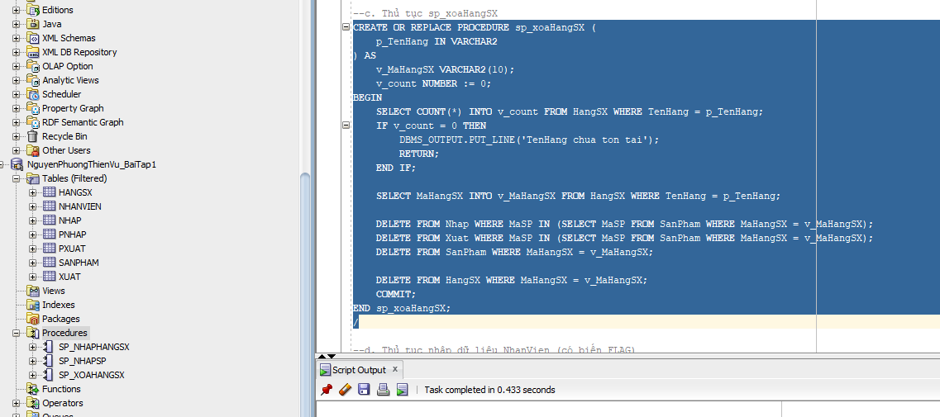
d. Thủ tục nhập dữ liệu NhanVien (có biến FLAG)
CREATE OR REPLACE PROCEDURE sp_NhapNhanVien (
p_MaNV IN VARCHAR2,
p_TenNV IN VARCHAR2,
p_GioiTinh IN VARCHAR2,
p_DiaChi IN VARCHAR2,
p_SoDT IN VARCHAR2,
p_Email IN VARCHAR2,
p_TenPhong IN VARCHAR2,
p_Flag IN NUMBER
) AS
BEGIN
IF p_Flag = 0 THEN
UPDATE NhanVien
SET TenNV = p_TenNV, GioiTinh = p_GioiTinh, DiaChi = p_DiaChi,
SoDT = p_SoDT, Email = p_Email, TenPhong = p_TenPhong
WHERE MaNV = p_MaNV;
ELSE
INSERT INTO NhanVien (MaNV, TenNV, GioiTinh, DiaChi, SoDT, Email, TenPhong)
VALUES (p_MaNV, p_TenNV, p_GioiTinh, p_DiaChi, p_SoDT, p_Email, p_TenPhong);
END IF;
COMMIT;
END sp_NhapNhanVien;
/
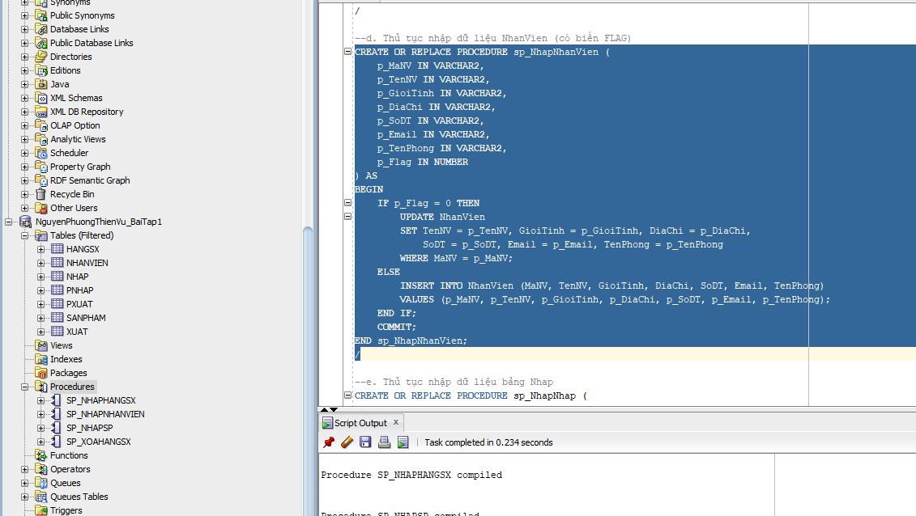
e. Thủ tục nhập dữ liệu bảng Nhap
CREATE OR REPLACE PROCEDURE sp_NhapNhap (
p_SoHDN IN VARCHAR2,
p_MaSP IN VARCHAR2,
p_MaNV IN VARCHAR2,
p_NgayNhap IN DATE,
p_SoLuongN IN NUMBER,
p_DonGiaN IN NUMBER
) AS
v_count NUMBER := 0;
BEGIN
SELECT COUNT(*) INTO v_count FROM SanPham WHERE MaSP = p_MaSP;
IF v_count = 0 THEN
DBMS_OUTPUT.PUT_LINE('MaSP khong ton tai');
RETURN;
END IF;

SELECT COUNT(*) INTO v_count FROM NhanVien WHERE MaNV = p_MaNV;
IF v_count = 0 THEN
DBMS_OUTPUT.PUT_LINE('MaNV khong ton tai');
RETURN;
END IF;

SELECT COUNT(*) INTO v_count FROM PNhap WHERE SoHDN = p_SoHDN;
IF v_count > 0 THEN
UPDATE Nhap
SET SoLuongN = p_SoLuongN, DonGiaN = p_DonGiaN
WHERE SoHDN = p_SoHDN AND MaSP = p_MaSP;
ELSE
INSERT INTO PNhap (SoHDN, NgayNhap, MaNV)
VALUES (p_SoHDN, p_NgayNhap, p_MaNV);

INSERT INTO Nhap (SoHDN, MaSP, SoLuongN, DonGiaN)
VALUES (p_SoHDN, p_MaSP, p_SoLuongN, p_DonGiaN);
END IF;
COMMIT;
END sp_NhapNhap;
/
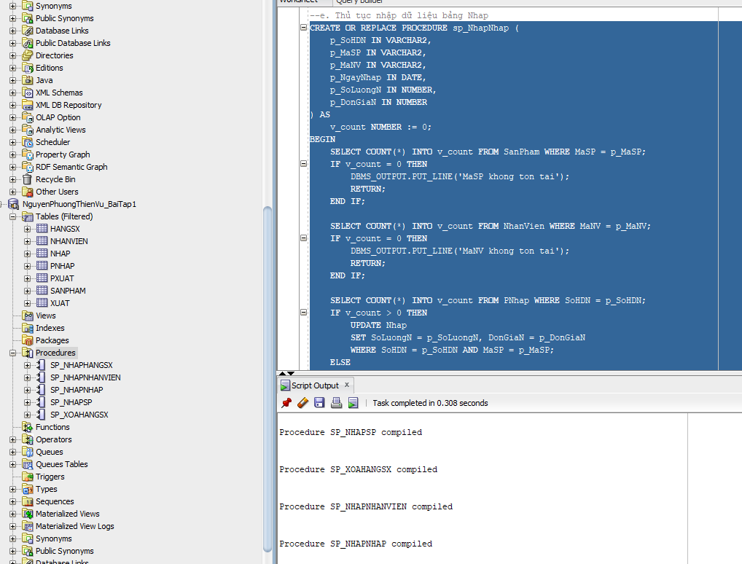
f. Thủ tục nhập dữ liệu bảng Xuat
CREATE OR REPLACE PROCEDURE sp_NhapXuat (
p_SoHDX IN VARCHAR2,
p_MaSP IN VARCHAR2,
p_MaNV IN VARCHAR2,
p_NgayXuat IN DATE,
p_SoLuongX IN NUMBER
) AS
v_count NUMBER := 0;
v_SoLuongTon NUMBER := 0;
BEGIN
SELECT COUNT(*) INTO v_count FROM SanPham WHERE MaSP = p_MaSP;
IF v_count = 0 THEN
DBMS_OUTPUT.PUT_LINE('MaSP khong ton tai');
RETURN;
END IF;

SELECT COUNT(*) INTO v_count FROM NhanVien WHERE MaNV = p_MaNV;
IF v_count = 0 THEN
DBMS_OUTPUT.PUT_LINE('MaNV khong ton tai');
RETURN;
END IF;

SELECT SoLuong INTO v_SoLuongTon FROM SanPham WHERE MaSP = p_MaSP;
IF p_SoLuongX > v_SoLuongTon THEN
DBMS_OUTPUT.PUT_LINE('Khong du hang');
RETURN;
END IF;

SELECT COUNT(*) INTO v_count FROM PXuat WHERE SoHDX = p_SoHDX;
IF v_count > 0 THEN
UPDATE Xuat
SET SoLuongX = p_SoLuongX
WHERE SoHDX = p_SoHDX AND MaSP = p_MaSP;
ELSE
INSERT INTO PXuat (SoHDX, NgayXuat, MaNV)
VALUES (p_SoHDX, p_NgayXuat, p_MaNV);

INSERT INTO Xuat (SoHDX, MaSP, SoLuongX)
VALUES (p_SoHDX, p_MaSP, p_SoLuongX);
END IF;
COMMIT;
END sp_NhapXuat;
/
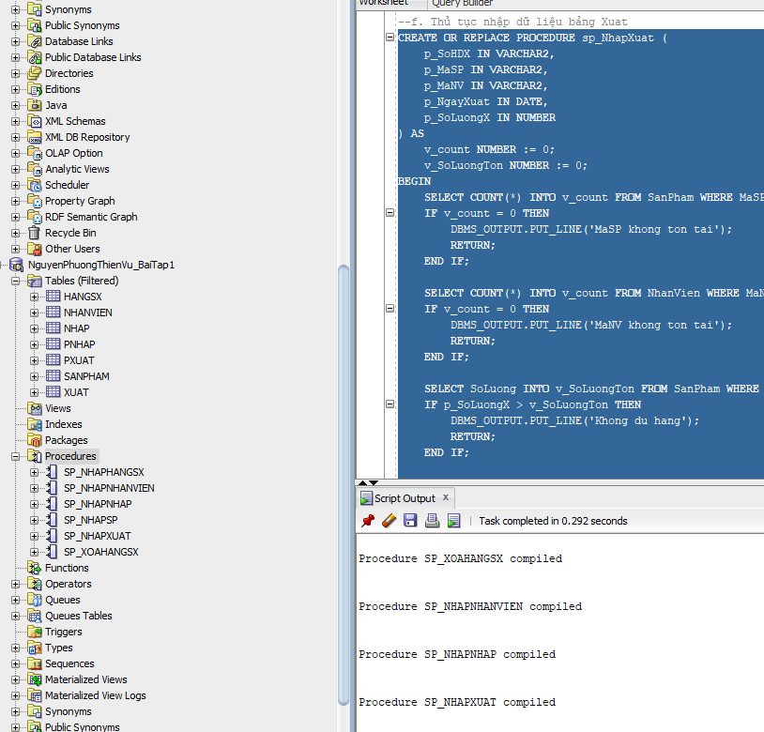
g. Thủ tục xóa NhanVien
CREATE OR REPLACE PROCEDURE sp_xoaNhanVien (
p_MaNV IN VARCHAR2
) AS
v_count NUMBER := 0;
BEGIN
SELECT COUNT(*) INTO v_count FROM NhanVien WHERE MaNV = p_MaNV;
IF v_count = 0 THEN
DBMS_OUTPUT.PUT_LINE('MaNV chua ton tai');
RETURN;
END IF;

DELETE FROM Nhap WHERE SoHDN IN (SELECT SoHDN FROM PNhap WHERE MaNV = p_MaNV);
DELETE FROM PNhap WHERE MaNV = p_MaNV;

DELETE FROM Xuat WHERE SoHDX IN (SELECT SoHDX FROM PXuat WHERE MaNV = p_MaNV);
DELETE FROM PXuat WHERE MaNV = p_MaNV;

DELETE FROM NhanVien WHERE MaNV = p_MaNV;
COMMIT;
END sp_xoaNhanVien;
/
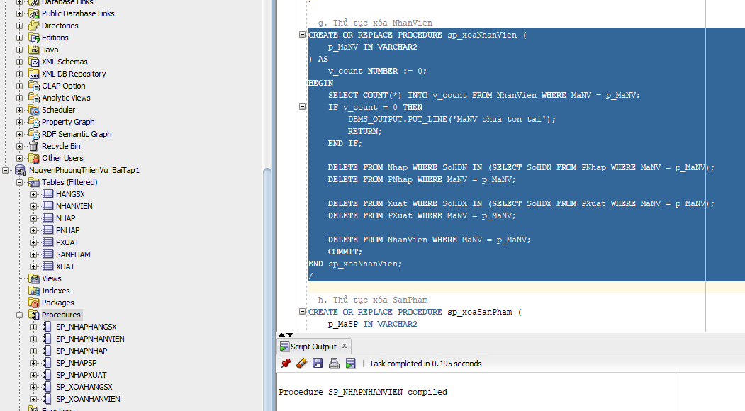
h. Thủ tục xóa SanPham
CREATE OR REPLACE PROCEDURE sp_xoaSanPham (
p_MaSP IN VARCHAR2
) AS
v_count NUMBER := 0;
BEGIN
SELECT COUNT(*) INTO v_count FROM SanPham WHERE MaSP = p_MaSP;
IF v_count = 0 THEN
DBMS_OUTPUT.PUT_LINE('MaSP chua ton tai');
RETURN;
END IF;

DELETE FROM Nhap WHERE MaSP = p_MaSP;
DELETE FROM Xuat WHERE MaSP = p_MaSP;

DELETE FROM SanPham WHERE MaSP = p_MaSP;
COMMIT;
END sp_xoaSanPham;
/
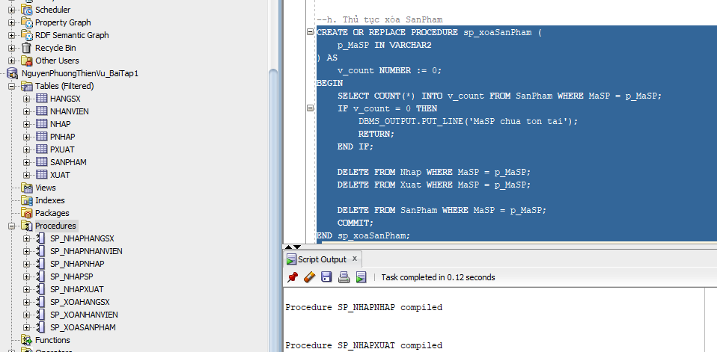

PHIẾU BÀI TẬP 2
a. Thủ tục sp_ThemNhanVien (có OUT)
CREATE OR REPLACE PROCEDURE sp_ThemNhanVien (
p_MaNV IN VARCHAR2,
p_TenNV IN VARCHAR2,
p_GioiTinh IN VARCHAR2,
p_DiaChi IN VARCHAR2,
p_SoDT IN VARCHAR2,
p_Email IN VARCHAR2,
p_TenPhong IN VARCHAR2,
p_Flag IN NUMBER,
p_KQ OUT NUMBER
) AS
BEGIN
p_KQ := 0;
IF p_GioiTinh <> 'Nam' AND p_GioiTinh <> 'Nu' THEN
p_KQ := 1;
RETURN;
END IF;

IF p_Flag = 0 THEN
INSERT INTO NhanVien (MaNV, TenNV, GioiTinh, DiaChi, SoDT, Email, TenPhong)
VALUES (p_MaNV, p_TenNV, p_GioiTinh, p_DiaChi, p_SoDT, p_Email, p_TenPhong);
ELSE
UPDATE NhanVien
SET TenNV = p_TenNV, GioiTinh = p_GioiTinh, DiaChi = p_DiaChi,
SoDT = p_SoDT, Email = p_Email, TenPhong = p_TenPhong
WHERE MaNV = p_MaNV;
END IF;
COMMIT;
END sp_ThemNhanVien;
/
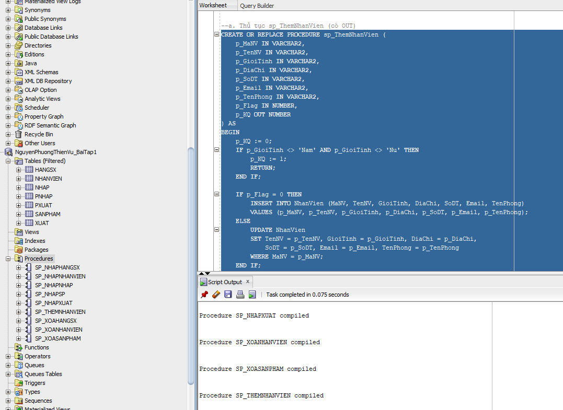
b. Thủ tục sp_ThemMoiSP (có OUT)
CREATE OR REPLACE PROCEDURE sp_ThemMoiSP (
p_MaSP IN VARCHAR2,
p_TenHang IN VARCHAR2,
p_TenSP IN VARCHAR2,
p_SoLuong IN NUMBER,
p_MauSac IN VARCHAR2,
p_GiaBan IN NUMBER,
p_DonViTinh IN VARCHAR2,
p_MoTa IN CLOB,
p_Flag IN NUMBER,
p_KQ OUT NUMBER
) AS
v_MaHangSX VARCHAR2(10);
v_count NUMBER := 0;
BEGIN
p_KQ := 0;

SELECT COUNT(*) INTO v_count FROM HangSX WHERE TenHang = p_TenHang;
IF v_count = 0 THEN
p_KQ := 1;
RETURN;
END IF;

SELECT MaHangSX INTO v_MaHangSX FROM HangSX WHERE TenHang = p_TenHang;

-- Kiểm tra SoLuong
IF p_SoLuong < 0 THEN
p_KQ := 2;
RETURN;
END IF;

IF p_Flag = 0 THEN
INSERT INTO SanPham (MaSP, MaHangSX, TenSP, SoLuong, MauSac, GiaBan, DonViTinh, MoTa)
VALUES (p_MaSP, v_MaHangSX, p_TenSP, p_SoLuong, p_MauSac, p_GiaBan, p_DonViTinh, p_MoTa);
ELSE
UPDATE SanPham
SET MaHangSX = v_MaHangSX, TenSP = p_TenSP, SoLuong = p_SoLuong, MauSac = p_MauSac,
GiaBan = p_GiaBan, DonViTinh = p_DonViTinh, MoTa = p_MoTa
WHERE MaSP = p_MaSP;
END IF;
COMMIT;
END sp_ThemMoiSP;
/
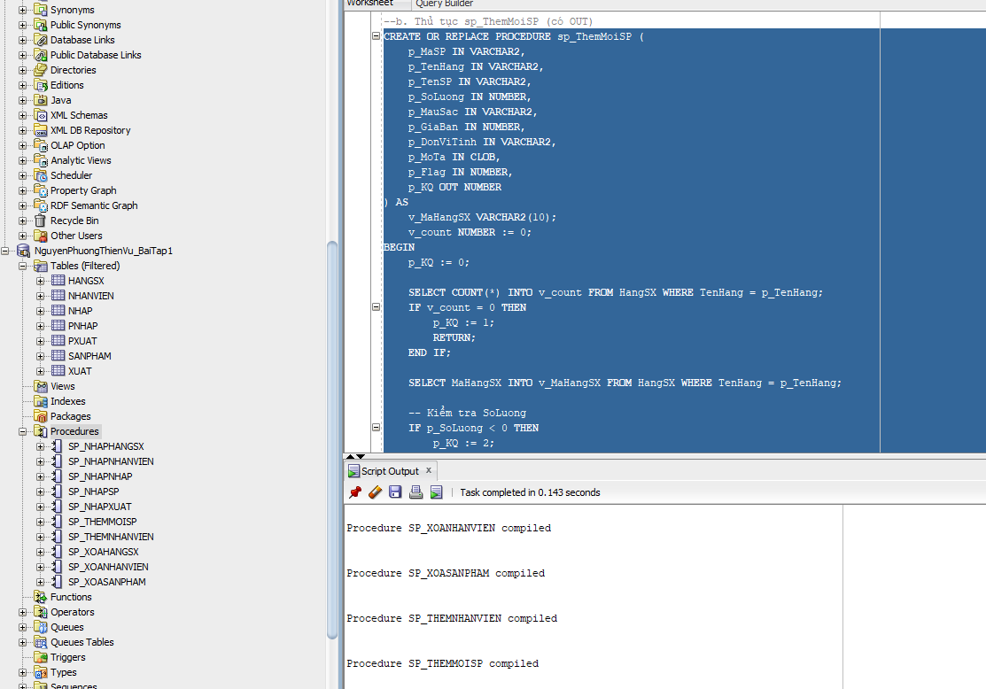
c. Thủ tục xóa NhanVien (có OUT)
CREATE OR REPLACE PROCEDURE sp_xoaNhanVien_OUT (
p_MaNV IN VARCHAR2,
p_KQ OUT NUMBER
) AS
v_count NUMBER := 0;
BEGIN
SELECT COUNT(*) INTO v_count FROM NhanVien WHERE MaNV = p_MaNV;
IF v_count = 0 THEN
p_KQ := 1;
RETURN;
END IF;

DELETE FROM Nhap WHERE SoHDN IN (SELECT SoHDN FROM PNhap WHERE MaNV = p_MaNV);
DELETE FROM PNhap WHERE MaNV = p_MaNV;

DELETE FROM Xuat WHERE SoHDX IN (SELECT SoHDX FROM PXuat WHERE MaNV = p_MaNV);
DELETE FROM PXuat WHERE MaNV = p_MaNV;

DELETE FROM NhanVien WHERE MaNV = p_MaNV;
COMMIT;
p_KQ := 0;
END sp_xoaNhanVien_OUT;
/
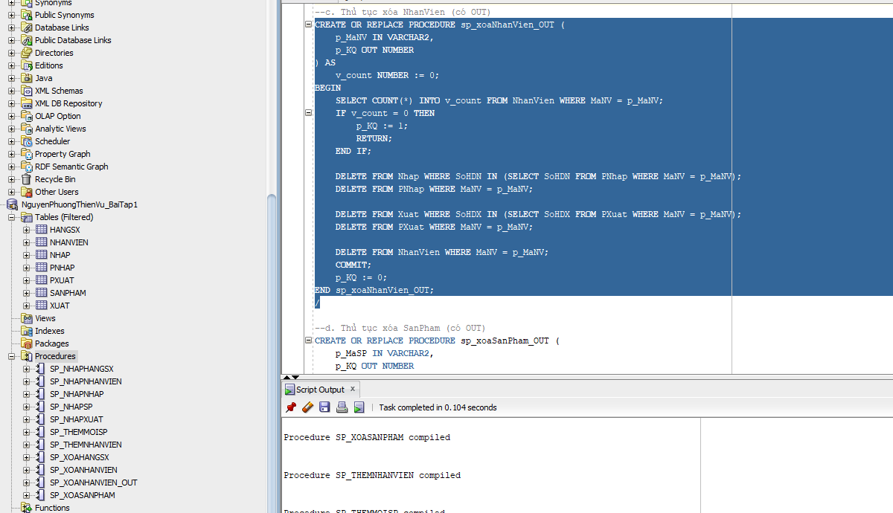
d. Thủ tục xóa SanPham (có OUT)
CREATE OR REPLACE PROCEDURE sp_xoaSanPham_OUT (
p_MaSP IN VARCHAR2,
p_KQ OUT NUMBER
) AS
v_count NUMBER := 0;
BEGIN
SELECT COUNT(*) INTO v_count FROM SanPham WHERE MaSP = p_MaSP;
IF v_count = 0 THEN
p_KQ := 1;
RETURN;
END IF;

DELETE FROM Nhap WHERE MaSP = p_MaSP;
DELETE FROM Xuat WHERE MaSP = p_MaSP;

DELETE FROM SanPham WHERE MaSP = p_MaSP;
COMMIT;
p_KQ := 0;
END sp_xoaSanPham_OUT;
/
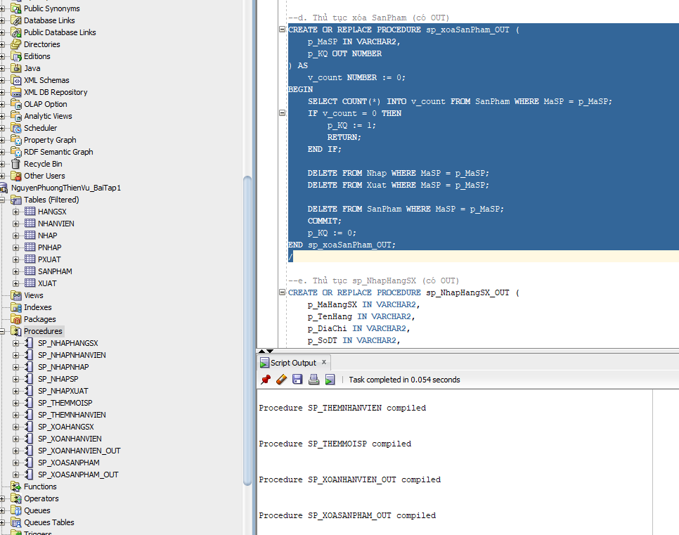
e. Thủ tục sp_NhapHangSX (có OUT)
CREATE OR REPLACE PROCEDURE sp_NhapHangSX_OUT (
p_MaHangSX IN VARCHAR2,
p_TenHang IN VARCHAR2,
p_DiaChi IN VARCHAR2,
p_SoDT IN VARCHAR2,
p_Email IN VARCHAR2,
p_KQ OUT NUMBER
) AS
v_count NUMBER := 0;
BEGIN
SELECT COUNT(*) INTO v_count FROM HangSX WHERE TenHang = p_TenHang;
IF v_count > 0 THEN
p_KQ := 1;
RETURN;
END IF;

INSERT INTO HangSX (MaHangSX, TenHang, DiaChi, SoDT, Email)
VALUES (p_MaHangSX, p_TenHang, p_DiaChi, p_SoDT, p_Email);
COMMIT;
p_KQ := 0;
END sp_NhapHangSX_OUT;
/
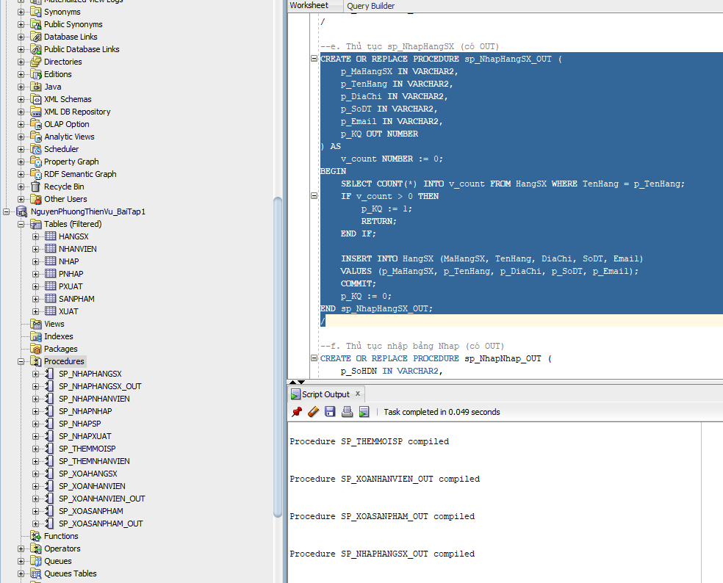
f. Thủ tục nhập bảng Nhap (có OUT)
CREATE OR REPLACE PROCEDURE sp_NhapNhap_OUT (
p_SoHDN IN VARCHAR2,
p_MaSP IN VARCHAR2,
p_MaNV IN VARCHAR2,
p_NgayNhap IN DATE,
p_SoLuongN IN NUMBER,
p_DonGiaN IN NUMBER,
p_KQ OUT NUMBER
) AS
v_count NUMBER := 0;
BEGIN
p_KQ := 0;

SELECT COUNT(*) INTO v_count FROM SanPham WHERE MaSP = p_MaSP;
IF v_count = 0 THEN
p_KQ := 1;
RETURN;
END IF;

SELECT COUNT(*) INTO v_count FROM NhanVien WHERE MaNV = p_MaNV;
IF v_count = 0 THEN
p_KQ := 2;
RETURN;
END IF;

SELECT COUNT(*) INTO v_count FROM PNhap WHERE SoHDN = p_SoHDN;
IF v_count > 0 THEN
UPDATE Nhap
SET SoLuongN = p_SoLuongN, DonGiaN = p_DonGiaN
WHERE SoHDN = p_SoHDN AND MaSP = p_MaSP;
ELSE
INSERT INTO PNhap (SoHDN, NgayNhap, MaNV)
VALUES (p_SoHDN, p_NgayNhap, p_MaNV);

INSERT INTO Nhap (SoHDN, MaSP, SoLuongN, DonGiaN)
VALUES (p_SoHDN, p_MaSP, p_SoLuongN, p_DonGiaN);
END IF;
COMMIT;
END sp_NhapNhap_OUT;
/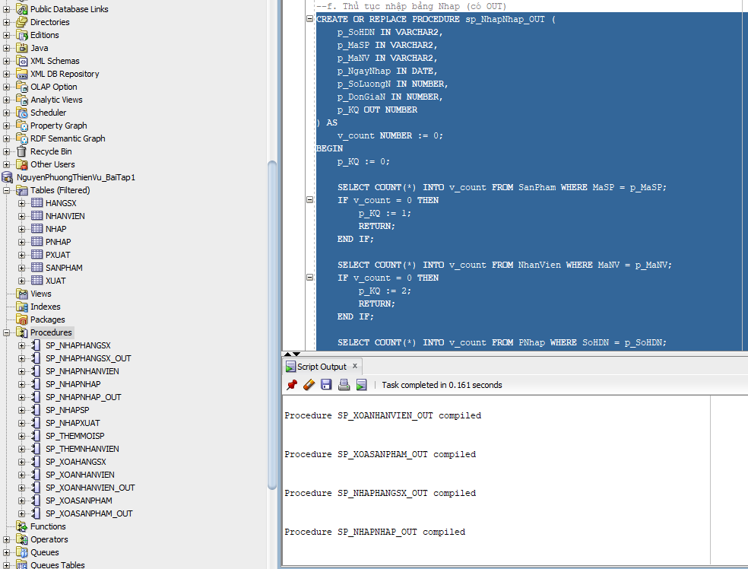
g. Thủ tục nhập bảng Xuat (có OUT)
CREATE OR REPLACE PROCEDURE sp_NhapXuat_OUT (
p_SoHDX IN VARCHAR2,
p_MaSP IN VARCHAR2,
p_MaNV IN VARCHAR2,
p_NgayXuat IN DATE,
p_SoLuongX IN NUMBER,
p_KQ OUT NUMBER
) AS
v_count NUMBER := 0;
v_SoLuongTon NUMBER := 0;
BEGIN
p_KQ := 0;

SELECT COUNT(*) INTO v_count FROM SanPham WHERE MaSP = p_MaSP;
IF v_count = 0 THEN
p_KQ := 1;
RETURN;
END IF;

SELECT COUNT(*) INTO v_count FROM NhanVien WHERE MaNV = p_MaNV;
IF v_count = 0 THEN
p_KQ := 2;
RETURN;
END IF;

SELECT SoLuong INTO v_SoLuongTon FROM SanPham WHERE MaSP = p_MaSP;
IF p_SoLuongX > v_SoLuongTon THEN
p_KQ := 3;
RETURN;
END IF;

SELECT COUNT(*) INTO v_count FROM PXuat WHERE SoHDX = p_SoHDX;
IF v_count > 0 THEN
UPDATE Xuat
SET SoLuongX = p_SoLuongX
WHERE SoHDX = p_SoHDX AND MaSP = p_MaSP;
ELSE
INSERT INTO PXuat (SoHDX, NgayXuat, MaNV)
VALUES (p_SoHDX, p_NgayXuat, p_MaNV);

INSERT INTO Xuat (SoHDX, MaSP, SoLuongX)
VALUES (p_SoHDX, p_MaSP, p_SoLuongX);
END IF;
COMMIT;
END sp_NhapXuat_OUT;
/
